1. Download the functions_v1.tns from dropbox
2. Download [TINspire Student Software](https://education.ti.com/en/us/software/details/en/372E071AFDF14AC48CA4518D95B706B3/ti-nspirecas_pc_trial) on your computer
3. Connect your calculator to the computer
4. 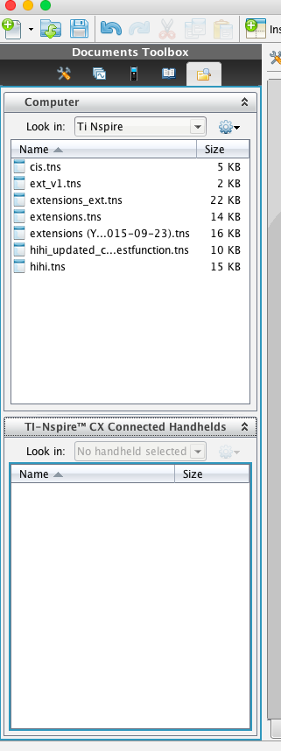Put the document in the MyLib directory on your calculator shown in the left picture
5. Go to your calculator and goto settings -> documents -> refresh library
6. Go to your calculator and open the functions_v1.tns on your calculator
7. Use and enjoy!